## Lab 2.3 – Building and Testing MLB leaning models

In this lab, we continue the work of the previous by building and testing various machine learning models for our two primary objectives, provided below.

**Research Questions.**

1. **Classification problem.** How well fielding statistics can be used to predict whether a player wins a gold glove at their position.
2. **Regression problem.** How well batting, pitching, and fielding statistics help predict a player’s salaries.

**Tasks.** Perform each of the following tasks before constructing the two data sets.

1. Perform a grid search for both single trees—as well as Random Forests—to find the best performing model for each problem.
2. In each case, validate the winning model by testing its performance on the validation data.
3. Write up a short report summarizing your findings.

<https://github.com/tasha-koehl/Lab_3>

Classification

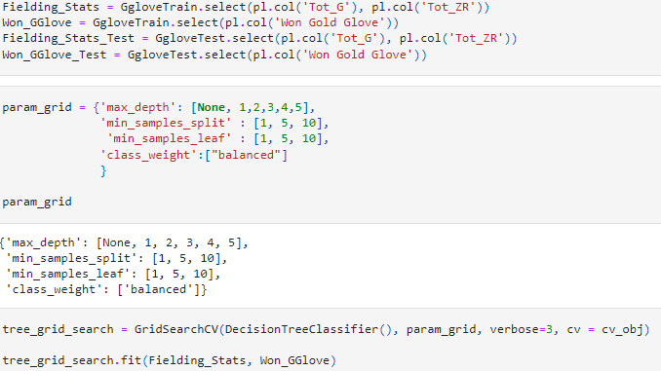

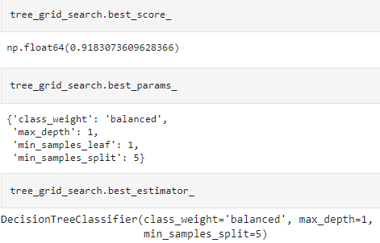

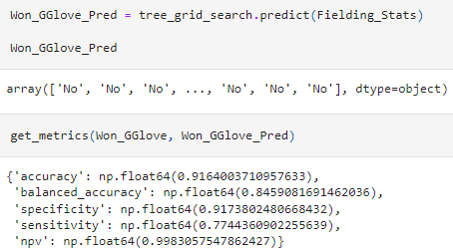

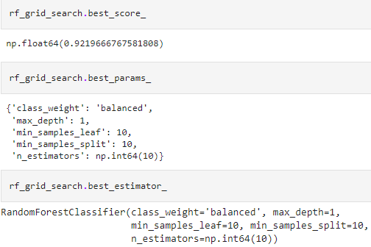

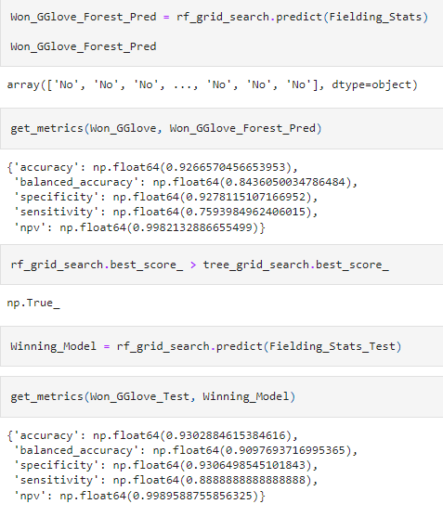

Regression



